MONDAY BELLRINGER 9/15/14
Name

- Compare using <, >, or =.

0.017 0.0017
- Write the following number in standard form. Two hundred forty-eight hundred thousandths

- Find the quotient. (Show your work.)
569 ÷ 7

_______________________________

- Find the product. (Show your work.)

56 x 2

_______________________________

5. Write $\frac{84}{100}$ as a decimal.

TUESDAY BELLRINGER 9/16/14
Name

- Kelly wants to purchase 90 stickers for
her friends. Stickers come in packages of 20. How many packages will Kelly need to purchase?

- List in order from least to greatest.
67.8, 6.78, 7.86, 6.078, 6, 7

- Compare using <, >, or =.
56.8907 56.89007

4. Write in word form. 2.00789

5. Write 0.4 as a fraction.

WEDNESDAY BELLRINGER 9/17/14
Name

- Order from least to greatest.
56.943, 5.943, 5, 6.945, 6

- Find the quotient. (Show your work.)
409 ÷ 8

- Write the first five multiples for the
number 8.

, , , ,

- Mrs. Tosh spots a steal of a deal on Star
War pencils at Target. She would like to buy at least 500 pencils. Pencils come in packages of eight. How many packages will she need to purchase?

- Convert the improper fraction to a mixed
number.

$\frac{23}{5}$

THURSDAY BELLRINGER 9/18/14
Name

- Name a fraction that is equivalent to
102.86.

2. Write the place value of the underlined digit.
86,007.002001

8:

2:

1:

3. Write 0.18 as a fraction.

4. Fill in the missing numerator.

0.0148 =
10,000

5. Find the quotient of the division problem. (Show your work.)
790 ÷ 8

FRIDAY BELLRINGER, September 19 Name

- Write a number that is equivalent to nine and twelve hundredths.

- Compare using <, >, or =. 0.100120 0.100123

- Write the value of the underlined digit. 154,897.00987

- Write the fraction as an equivalent decimal. $\frac{543}{1000}$
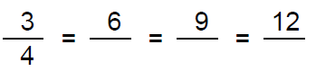
- Fill in the missing denominators for the
fractions equivalent to ¾.

FRIDAY BELLRINGER, September 19 Name

- Write a number that is equivalent to nine and twelve hundredths.

- Compare using <, >, or =. 0.100120 0.100123

- Write the value of the underlined digit. 154,897.00987

- Write the fraction as an equivalent decimal. $\frac{543}{1000}$
- Fill in the missing denominators for the
fractions equivalent to ¾.

MONDAY HOMEWORK, September 15 Name

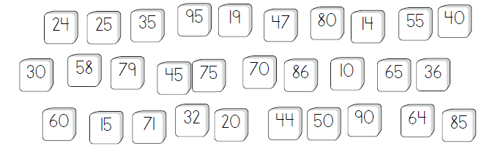
- Shade the numbers which are multiples of 5.

- Order the following numbers from least to greatest: 8, 9.8, 7.89, 9, 9,78

- Write the number in WORD FORM. 0.000235

- A box of Capri Sun has 10 drink pouches. If Ms. Rheinecker wants to buy a Capri Sun for each of the 179 fifth graders as a reward, how many boxes will she need to purchase in order to have a Capri Sun for everyone?

TUESDAY HOMEWORK, September 16 Name

- Compare the decimals. In each pair, which decimal is greater? Circle the larger decimal.

7.9 and 8.1 0.5 and 0.62 3.6 and 0.94

- Find the product. (Show your work.) 459 x 81

- Convert the improper fraction $\frac{51}{6}$ to a mixed number.

- Write the VALUE of the underlined digit. 9,872,308.0374232

- Write 901.876 in EXPANDED FORM.

WEDNESDAY HOMEWORK, September 17 Name

- Write $\frac{38}{1,000}$ as a decimal.

- Find the product. (Show your work.) 42 x 16

- Name the equivalent fraction for 0.6

- Write the PLACE VALUE of the underlined digit. 36,874.2095

6: 2: 9:

- A shop sells 4 chairs in a set. Which of the following numbers of chairs make complete sets? Circle your answer and show a model of the correct answers.

10, 12, 15, 20, 22, 28, 35

THURSDAY HOMEWORK, September 18 Name

- Find the quotient. (Show your work.) 9,867 ÷ 9

- Write the number in standard form.
four thousand and two hundred ninety-six hundred thousandths

- Find the product. (Show your work.) 46 x 8 =

- The Weather Bureau reported 5.18 inches of rain in March, 6.74 inches in April, and 5.23 inches in May. Which month had the least rainfall? Why?

- Compare using <, >, or =.

0.00036 0.036001 9.0010 9.001000

