Monday HOMEWORK, December 1 Name
- Mrs. Tosh had two and forty-two thousandths pounds of turkey left over after Thanksgiving. Write two and forty-two thousandths in STANDARD FORM.

- The Macy’s Thanksgiving Parade has been a tradition in New York City since 1924. The average balloon in the parade requires 12,000 cubic feet of helium. If there were sixteen balloons, how much helium would be needed for all the balloons?

- Circle the correct answer. 0.125 ( ˃ ˂ =) $\frac{3}{20}$

- Arrange in order from greatest to least. 0.25,$\frac{1}{5}$ , 0.8, $\frac{2}{3}$

- List the first five multiples of the number six.

Tuesday HOMEWORK, December 2 Name
- Ms. Linde is making her class budget for supplies. She needs 62 packs of Expo markers. If each pack costs $12, how much will her total be for Expo markers?

- What mixed number is equivalent to $\frac{37}{6}$ ?

- What is the GCF (Greatest Common Factor) of 16 and 40?

- A meet market has 48 pounds of meat to place into nine packs. How many pounds of meat will be in each pack?

Wednesday HOMEWORK, December 3 Name

- My sister and I ate part of a chocolate bar. She ate $\frac{3}{5}$ of it and I ate $\frac{1}{10}$ of it. How much of the chocolate bar did we eat?

- The pizza shop delivered 130 slices of pizza for a class of 27 students. How many whole pieces of pizza will each student get to eat? The teachers get to share the leftover pieces. How many pieces are left over?

- Name an equivalent fraction for 0.08. In simplest form?
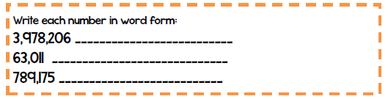

Thursday HOMEWORK, December 4 Name

- We brought 50 gallons of water on our camping trip. If 14 people go on the trip, how much water will each camper get to drink during the trip?

- A piece of fruit weighed 9.34 ounces. Express 9.34 as a mixed number in simplest form.

- Circle the correct answer. 46.23 ( ˃ ˂ =) 46 $\frac{1}{3}$

- Solve. Show your work!
