HOMEWORK Name
MONDAY, AUGUST 11 Directions: Please show your work and find the product of each multiplication problem.

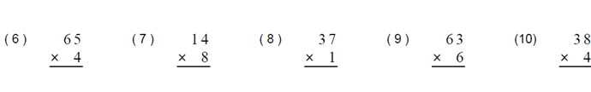

HOMEWORK Name
TUESDAY, AUGUST 12 Directions: Please show your work and find the product of each multiplication problem.

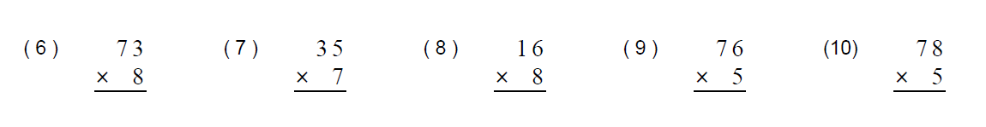

HOMEWORK Name
WEDNESDAY, AUGUST 13 Directions: Please show your work and find the product of each multiplication problem. 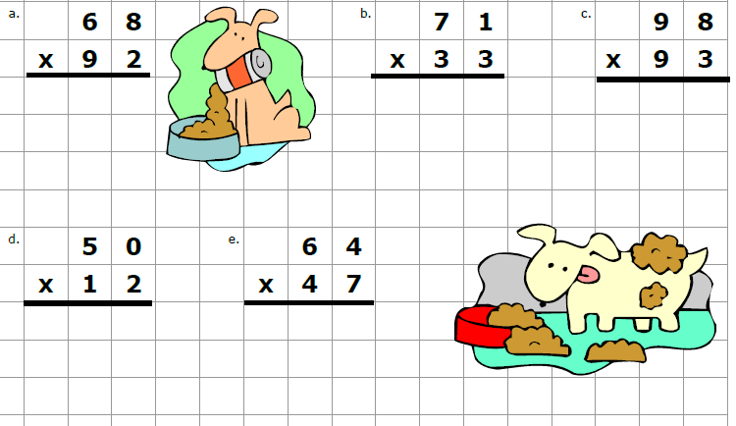
HOMEWORK Name
THURSDAY, AUGUST 14 Directions: Please show your work and find the product of each multiplication problem.
