Homework for MONDAY, AUGUST 24 Name
- Write 1,890,365:
- word form

- expanded form

- expanded base ten form

- What is the value of the 2 in 12,369?

- Increase the number 548,709 by 100,000. What is the new number?

- What is the place value of the 3 in 3,790,960?

Homework for TUESDAY, AUGUST 25 Name
Write the place value of the underlined digit.
1. 4,632,987 _________________________

2. 5,198,746 _________________________
Please complete the following table.
Number | 10 times as much | 1/10 as much
150
 | 8,200
 |  | 4

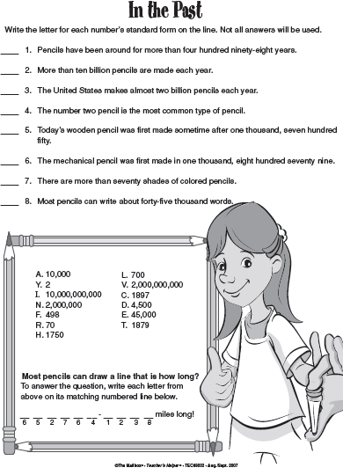
Homework for
WEDNESDAY, AUGUST 26 Name

Homework for THURSDAY, AUGUST 27 Name

1. Write the value of the underlined digit. 6,487,190
2. What number is 1/10 the value of 23,000?
3. Write in word form.
18,392 __________________________________________________________
_________________________________________________________________
4. Write in standard form.
_________________________
nine million, eight hundred twenty-six thousand, two hundred forty-six

