Monday HOMEWORK, November 17 Name
- Write eight million, two hundred ninety-eight thousand, two hundred forty-seven and nineteen millionths in STANDARD FORM.

- Ms. Talley used 133 yards of cloth to make window curtains. She made 7 curtains and used the same amount of cloth for each curtain. Exactly how many yards of cloth did Ms. Talley use for each curtain?

- Circle the correct answer. 9.14 ( ˃ ˂ =) 9 $\frac{1}{4}$

- Arrange in order from least to greatest. 0.65,$\frac{3}{5}$ , $\frac{1}{3}$, 0.4

- Find the quotient of 372 ÷ 7.

Tuesday HOMEWORK, November 18 Name
- Mrs. Coble has a book with 364 pages. There are 14 chapters in her book. Each chapter has the same number of pages. How many pages are in each chapter of Mrs. Coble’s book?

- What mixed number is equivalent to $\frac{48}{5}$ ?

- Find the product of 852 x 6.

- Ms. Hatcher placed an order for 225 DMS hoodies. She can fit 10 hoodies into a bag. How many full bags will Ms. Hatcher have? How many hoodies will be left over?

Wednesday HOMEWORK, November 19 Name

- A restaurant wants to buy 672 plastic forks. The forks come in packs of 12. How many packs will they need to buy?

- A grocery store boxes oranges in cartons of 36 each. They have received 156 cartons this year. How many total oranges has the store received this year?

- List the first 5 multiples of 8.

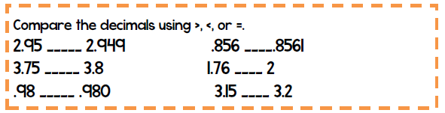

Thursday HOMEWORK, November 20 Name

- A bakery has 245 dozen cupcakes. How many individual cupcakes are there?
(Hint: There are 12 in a dozen.)

- A tour group has $784 to spend on tickets. If each ticket costs $7, how many tickets will the group be able to buy?

- Write a fraction equivalent to 32.4.
Can you name another equivalent fraction for 32.4?

