HOMEWORK Name
MONDAY, AUGUST 15 Directions: Please show your work and find the product of each multiplication problem.

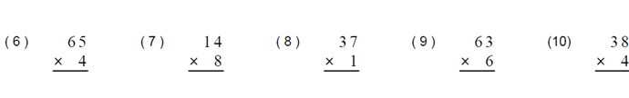

HOMEWORK Name
TUESDAY, AUGUST 16 Directions: Please show your work and find the product of each multiplication problem.

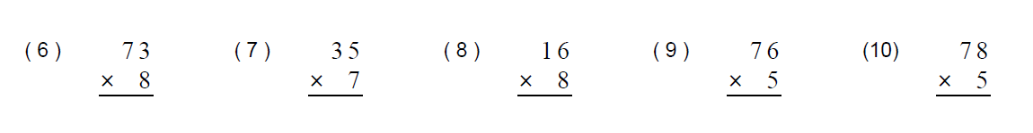

HOMEWORK Name
WEDNESDAY, AUGUST 17 Directions: Please show your work and find the product of each multiplication problem. 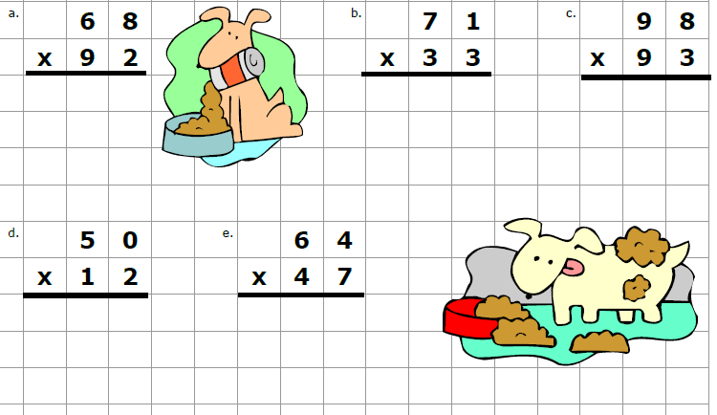
HOMEWORK Name
THURSDAY, AUGUST 18 Directions: Please show your work and find the product of each multiplication problem.
