MONDAY HOMEWORK, August 31 Name

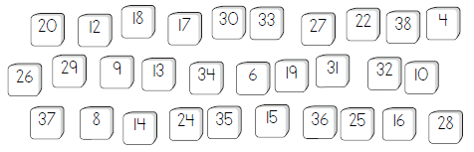
- Shade the numbers which are multiples of 2.

- Write the VALUE of the underlined digit: 2,578,163

- What is 1/10 the value of 8,000?

- What is 100 times the value of 30?

- Write 2³ in expanded form.

TUESDAY HOMEWORK, September 1 Name
- Write the following number in expanded form: 2,465,023

- Write the following number in word form: 6,900,014

Number | 1/10 the value | 10 times the value
60

1,500

 | 250

WEDNESDAY HOMEWORK, September 2 Name
- 89 x 5 (Show your multiplication work in the space below.)

- How is 3 x 3 x 3 x 3 written in exponential form?

- Write the VALUE of the underlined digit. 809,384

- Write in base ten form: nineteen thousand, two hundred seven

- Write in word form: 87,453

THURSDAY HOMEWORK, September 3 Name
Directions: Practice your multiplication skills by multiplying the numbers in each group and circle your final answer. (If you use another method to multiply, please use the back of the sheet to show work.)
