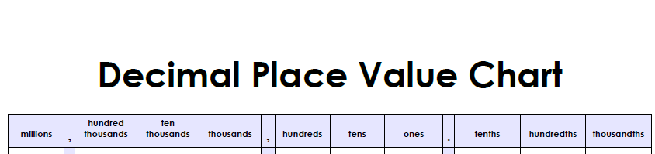
Weekly Homework for Sept. 19-23, 2016 Name

MONDAY Directions: Write each number in word form.
1. 6,429,165 Example: six million, four hundred twenty-nine thousand, one hundred sixty-five
2. 147,028

3. 19.4

4. 93,028

5. 7,620.731

TUESDAY Directions: Write each number in standard form.
Example: 8,287,426 1. eight million, two hundred eighty-seven thousand,
four hundred twenty-six

2. eight thousand, six hundred forty-two and six tenths

3. four million, eight hundred twenty-two thousand, nine
hundred eighty-six

4. four hundred eighty-nine thousand,
seven hundred twenty-four

5. four thousand and two hundredths

WEDNESDAY Directions: Write the value of the underlined digit.

Example: 0.8 1. 63.891

2. 1,239.986

3. 6,903,210

4. 3.452

5. 682.138

THURSDAY Directions: Write each number in expanded form.

1. 6,481,293 Example: 6,000,000 + 400,000 + 80,000 + 1,000 + 200 + 90 + 3

2. 193.648

3. 86,193

4. 312.9

